Health Information System Database Group Project

C-DE 312

Adham Sobhy - 23-101003

Youssef Walid - 22-101048

Mohamed Mostafa - 22-101203

Mohamed Ibrahim - 22-101058

Table of Contents

Phase 1 3

Requirements and Business Rules 3

1. Patient Management 3

2. Health Provider Management 3

3. Appointment System 3

4. Health Record Management 4

5. Insurance and Payment 4

6. Regulatory Compliance 4

ERD Diagram 4

Phase 2 5

Relational Schema 5

Phase 3 5

Sample of the 8 non-trivial SQL statements 5

Phase 4 9

Sample of the Functional dependencies 9

Phase 5 10

HIN Database Application 10

Main page including all tables 10

Example of operations made for each table 11

Select options 11

Inserting data into tables 12

Updating Data 12

Deleting Data 13

Joining tables with conditions and join types 13

# Phase 1

## Requirements and Business Rules

The Health Information Network (HIN) system is a national web-based platform that

manages and exchanges health records in compliance with HIPAA standards. The

system supports three main types of stakeholders: **patients**, **health providers**, and

**government regulators**.

Below are the database requirements and business rules that define the constraints for

the system:

### 1. Patient Management

* A patient must have a **unique ID** in the system.
* A patient can access and view their own **health records**.
* Each patient can maintain a list of **caregivers** (family or friends) who will be

○ notified in case of an emergency.

○ A patient may have zero or more associated caregivers but can add or remove

Caregivers at any time.

○ Caregiver notifications can be sent via **email** and/or **SMS**.

* Health insurance information is **optional** for patients.

○ If a patient has health insurance, it must be linked to only **one** registered

**insurance company** in the system.

○ If a patient does not have insurance, they must pay for services via **credit**

**card**, **bank transfer**, or **cash**.

* A patient can make appointment requests with health providers, and these

○ Requests must be based on the patient's treatment history and illness type.

○ Patients can cancel or change appointments.

### 2. Health Provider Management

● Each health provider in the system must have a **unique ID**, as well as their

**specialty**, **location**, and **availability** for appointments.

● A health provider can have multiple patients, but each patient can only have one

active appointment with a provider at any given time.

● **Emergency appointments take precedence** over regular appointments based

on availability.

### 3. Appointment System

● An **appointment** is identified by a **unique ID** and includes the date, time, type of

illness, and emergency status.

● Patients can request appointments, and the system automatically assigns them

to a health provider.

● **Appointment changes** are possible depending on the provider's availability and

the nature of the illness.

### 4. Health Record Management

● Each patient has a **collection of health records** that must include details such

as the date of the incident, type of illness, and treatment details.

● **Health records must be updated** by health providers after each appointment

and made accessible to patients.

● The system ensures **HIPAA compliance** by tracking all data exchanges between

patients, providers, and regulators.

○ Every time a provider accesses patient health records, pairwise evidence

is generated for regulatory and audit purposes.

### 5. Insurance and Payment

● **A patient’s insurance status** determines their payment method:

○ Patients with insurance are charged through their **health insurance**

**company**, based on their **insurance package**.

○ Uninsured patients must pay using a **credit card**, **bank transfer**, or **cash**.

● **A health insurance company must be registered** in the system before it can

be associated with patients.

● Payments for each appointment must be logged in the system, including the

**amount**, **payment method**, and **payment date**.

### 6. Regulatory Compliance

● **Government regulators** have access to all **health records** which allows them to

monitor nationwide health trends and ensure HIPAA compliance.

● Regulators must be able to track data flows and verify that patient information

shared between providers and the system is compliant with HIPAA standards.

○ **Evidence logs** must be created every time patient information is shared,

recording the data exchanged and the entities involved.

● Regulators can run **custom reports** to monitor trends related to illness,

treatments, and patient outcomes at a national level.

## ERD Diagram

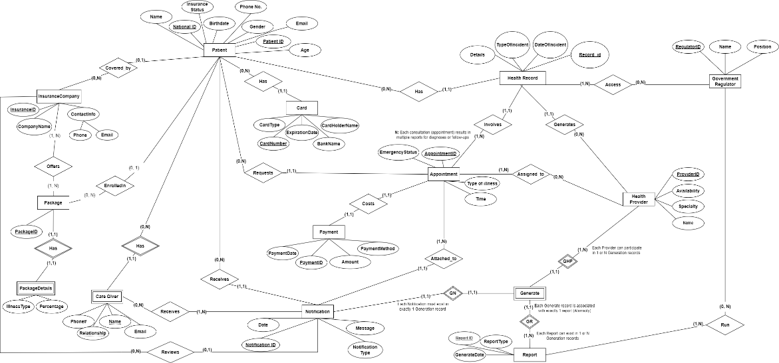

# Phase 2

## Relational Schema

# Phase 3

## Sample of the 8 non-trivial SQL statements

# Phase 4

## Sample of the Functional dependencies

1. GovernmentRegualtorReports:

Functional Dependencies:

**Attributes**: ReportID, RegulatorID

ReportID, RegulatorID → {all attributes}

Normalization:

**BCNF**: All attributes are determined by a superkey and there are no transitive dependencies.

1. Report:

Functional Dependencies:

**Attributes**: ReportID, ReportType, GenerateDate

ReportID → {all attributes}

Normalization:

**BCNF**: All attributes are determined by a superkey and there are no transitive dependencies.

1. HealthProvider:

Functional Dependencies:

**Attributes**: ProviderID, Availability, Specialty, Name

ProviderID → {all attributes}

Normalization:

**BCNF**: All attributes are determined by a superkey and there are no transitive dependencies.

# Phase 5

## HIN Database Application

## Main page including all tables

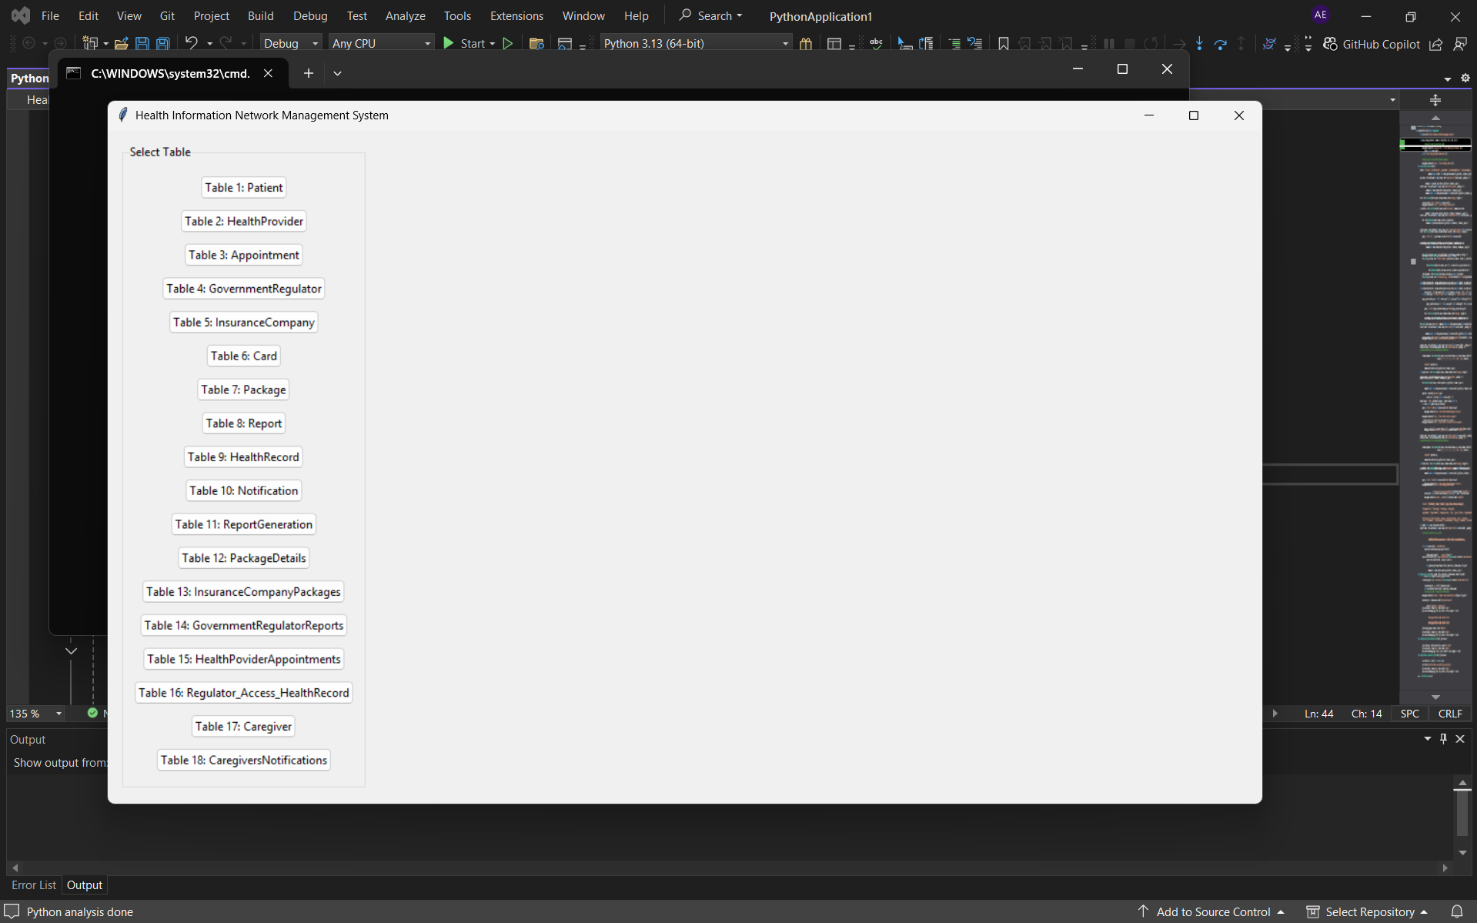

## Example of operations made for each table

## Select options

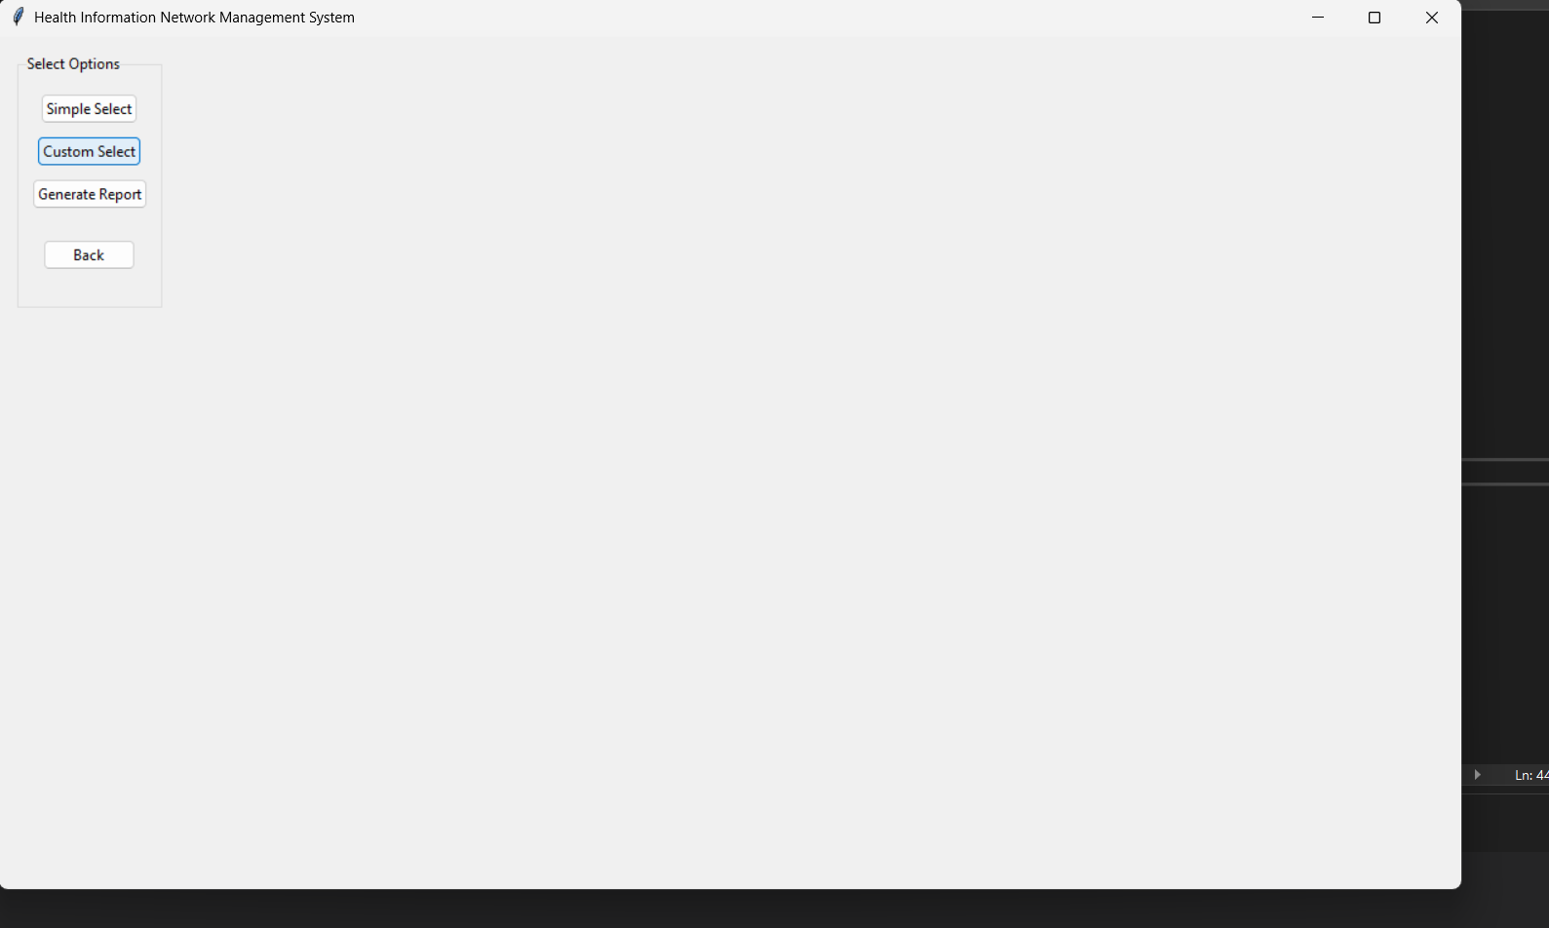

## Inserting data into tables

## Updating Data

## Deleting Data

## Joining tables with conditions and join types

